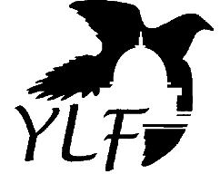 | Kansas Youth Leadership Forum  Volunteer Information

We are searching for committed, enthusiastic people who are willing to devote a week to this great program. Do you have the skills and passion to facilitate groups and motivate youth with disabilities? Then consider serving as a volunteer at the 2023 KSYLF to be held July 17-22, 2023!

What does a volunteer do?
The goal of all volunteers is to empower and support each delegate as they discover inner strengths and abilities as individuals and as members of a group. Volunteers are assigned to work with a small group throughout the week. They also interact with the large group during many activities. Our volunteers are the backbone of this program! They create the motivating, empowering atmosphere and serve as examples of leadership throughout the week. All volunteers must stay on campus for the duration of the week that KSYLF is taking place and must be present for all activities and sessions. Each volunteer has specific duties and is given a position based on their skills and experience. If selected as a volunteer, that person is an essential part of the team that ensures the success of the KSYLF week!

The Details…
- Volunteers must be at least 18 years old and have already graduated high school. They may be people with or without disabilities.

- Depending upon years of experience working with youth, past experience with the KSYLF, and individual abilities, volunteers will be designated as a facilitator, co-facilitator, or peer mentor.

- All volunteers will be assigned to work with a small group throughout the week. They will also be interacting with the large group during many activities.

- All volunteers are expected to stay on campus for the entire week of KSYLF (there will be no exceptions to this requirement, and volunteers will not be allowed to arrive late or leave early).

- All volunteers must participate in 2 pre-training Zoom calls months before the KSYLF. All volunteers must also complete a one-day staff orientation prior to the arrival of the youth.

- All volunteers must attend nightly staff meetings throughout the forum.

Volunteer Selection Procedure
- Interested volunteers fill out application and background checks and return to KYEA office by February 28, 2023.
- All potential volunteers are interviewed, over the phone, by the KSYLF Coordinator.
- Selection Team reviews all applications and selects qualified volunteers.
- Volunteer applicants are notified of the Selection Team’s decision. All applicants will be notified by April 2023.
- REMEMBER: All selected volunteers must participate in 2 pre-training Zoom calls months before the KSYLF on dates specified by KYEA.

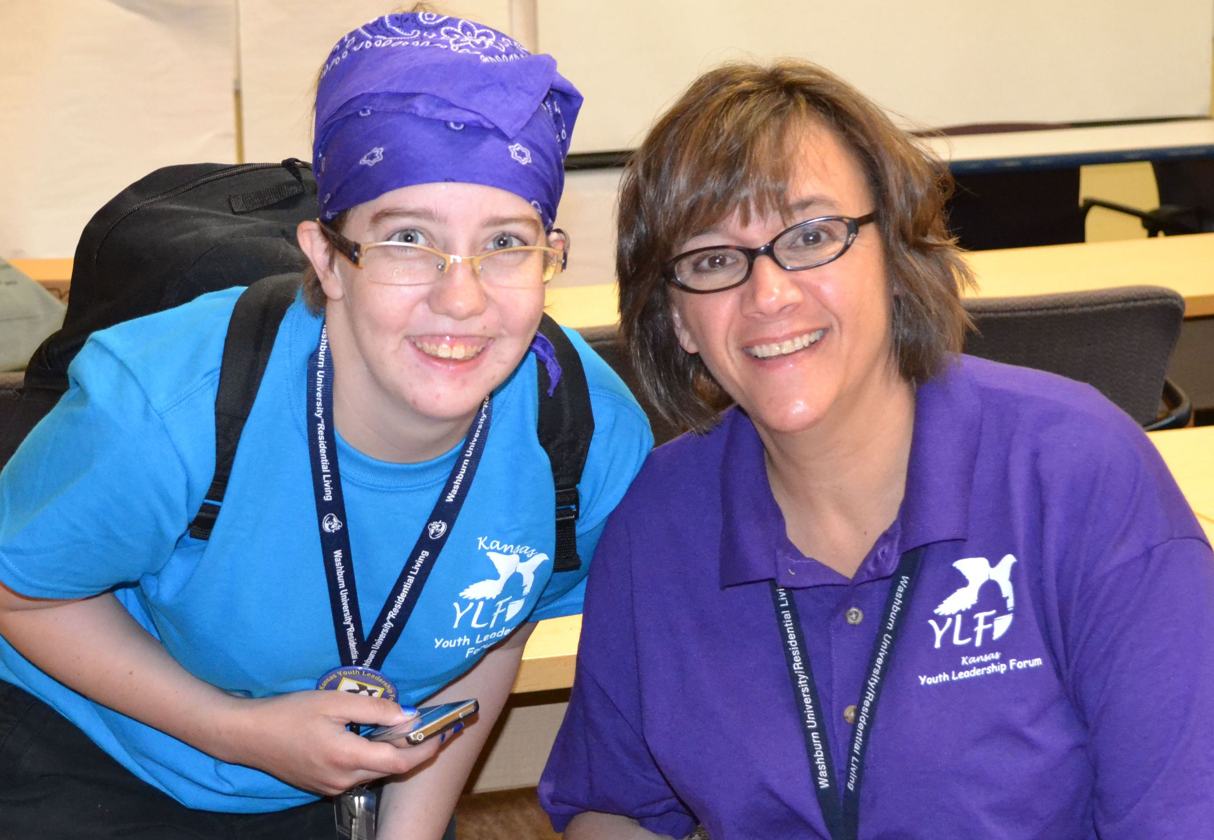
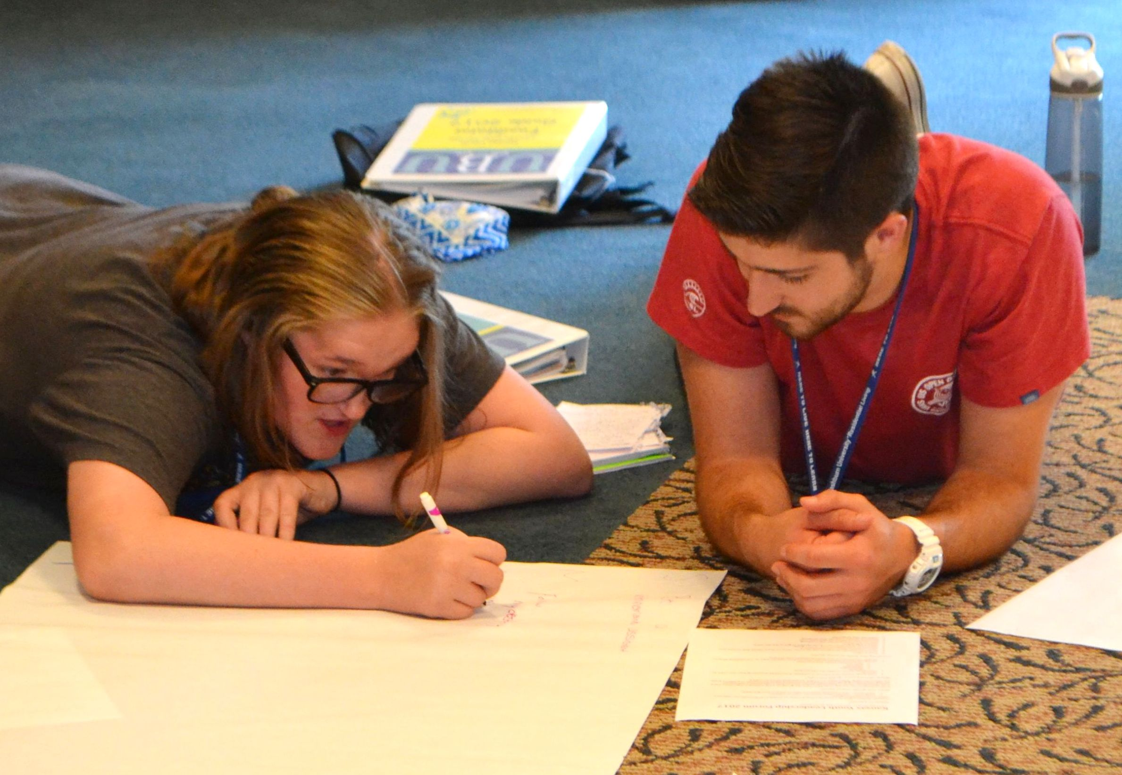
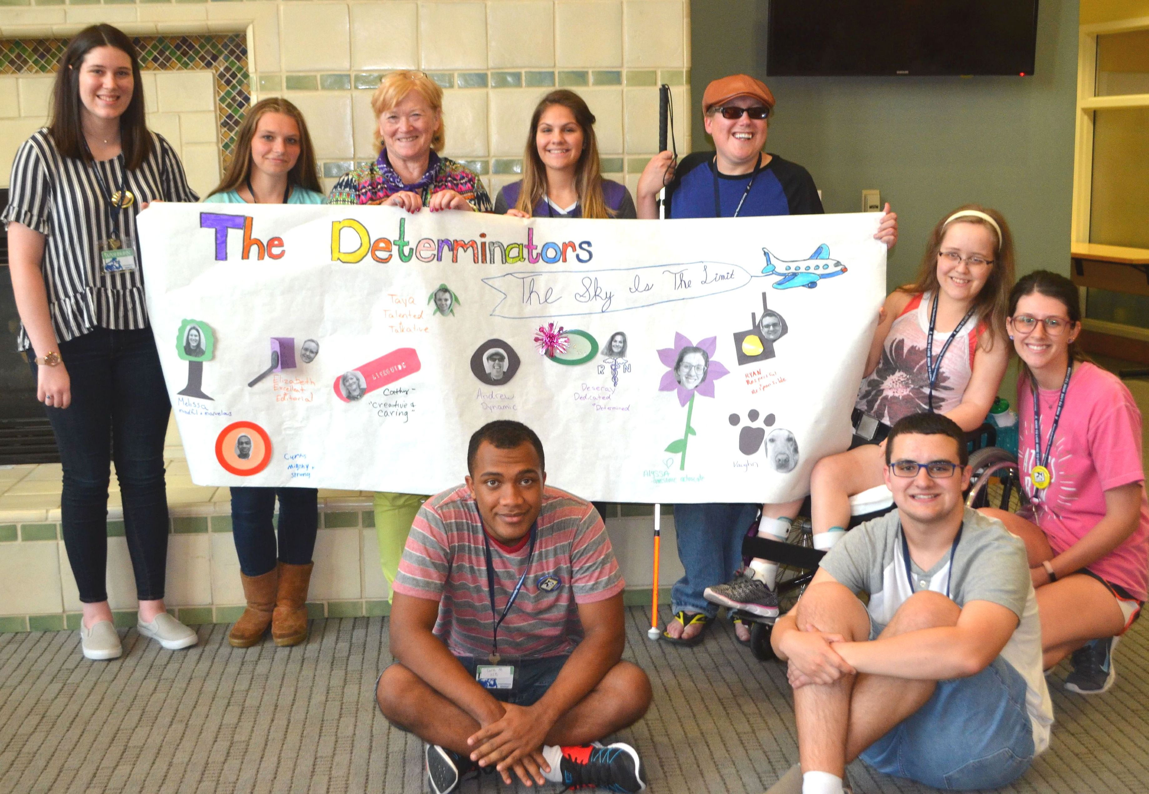
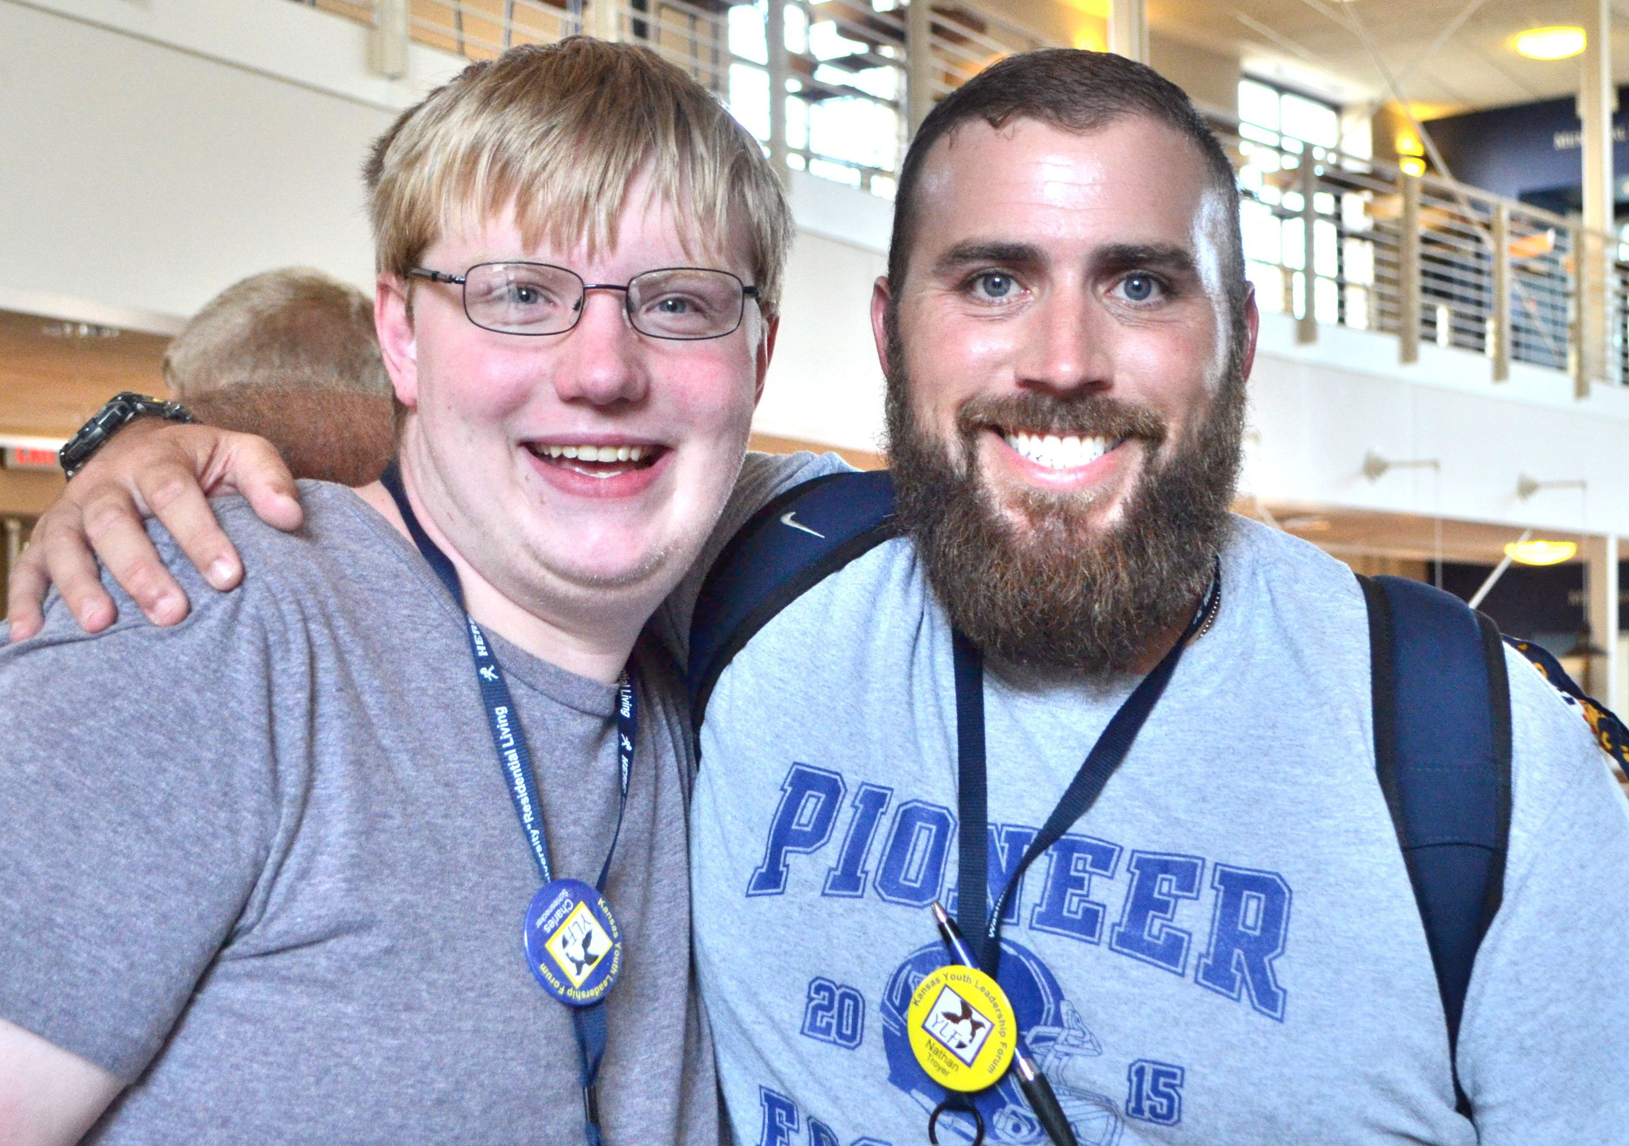
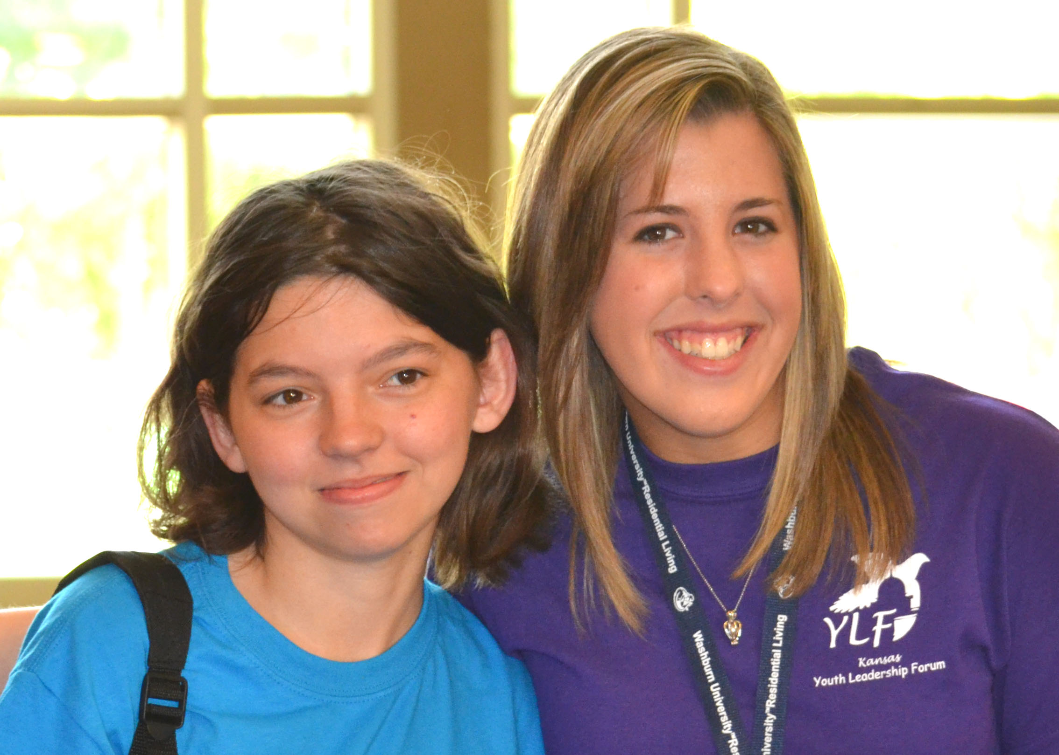
To obtain a volunteer application, or if you have questions, please contact Carrie at 785-215-6655 or carrieg@kyea.org, or visit our website at www.kyea.org.

